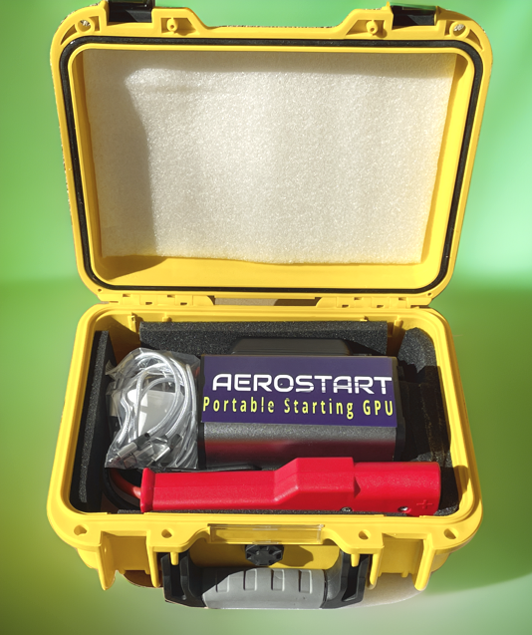
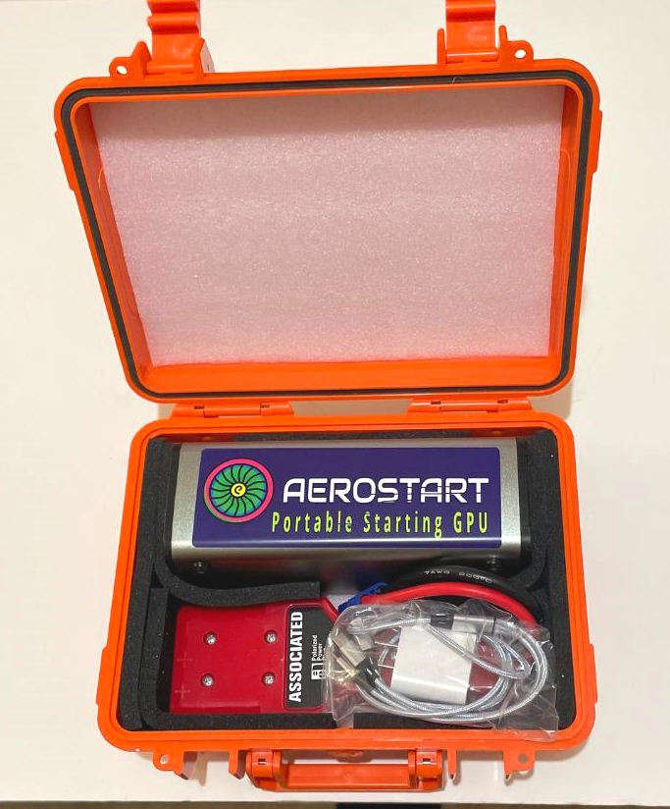
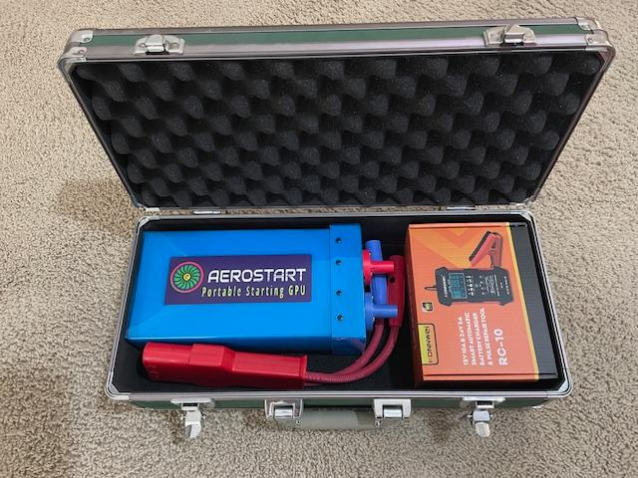
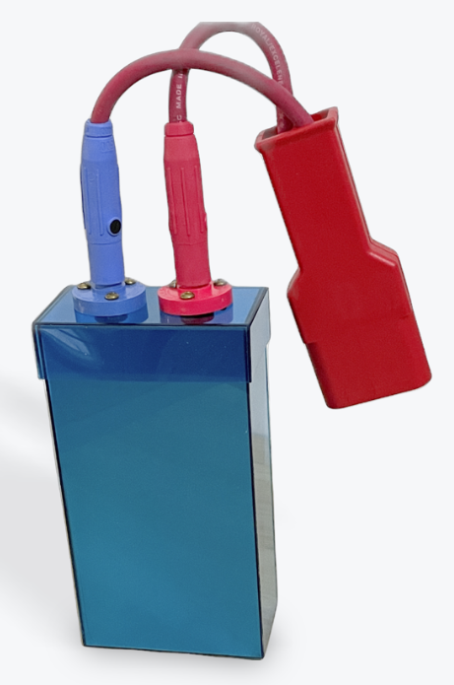
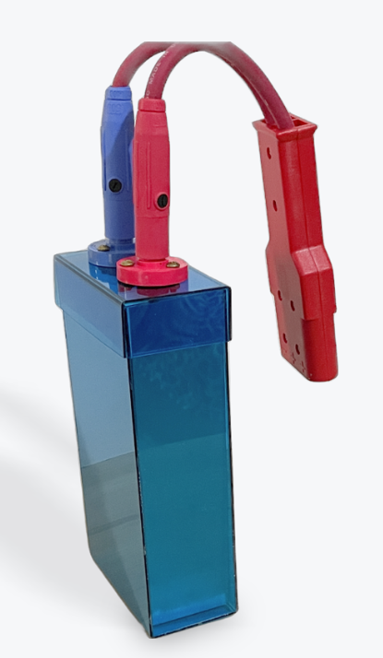

 | Nano - for all pistons | Micro piston  small turbines | Mini larger  turbines | Maxi large  turbines | Turbinator  biggest
AH Capacity | 9 | 12 | 16 | 30 | 40
Wh Energy | 189 | 324 | 432 | 810 | 1080
Voltage – freshly charged | 29.2 | 29.2 | 29.2 | 29.2 | 29.2
Voltage - Nominal | 26.8 | 26.8 | 26.8 | 26.8 | 26.8
Max Current Pulse Amps | 700 | 1000 | 2000 | 2600 | 3500
Max continuous Amps | 250 | 250 | 350 | 450 | 500
Terminal IR / Impedance | 12.6 | 9.3 | 8.3 | 6.9 | 2.9
Specific Power KW ( E x I ) | 8kw | 13kw | 21kw | 38kw | 48kw
WEIGHT / MASS lb / kg | 2.2 / 1 | 3.0 / 1.5 | 7.0 / 3.2 | 10 / 4.5 | 11 / 5.0
Dimensions | 5x3x3 | 8x3x3 | 9x6x3 | 11x6x3 | 16x5x4
# of starts | 2 - 3 | 2 - 3 | 2 - 3 | 2 - 3 | 2 - 3
Charge / Start cycles x 1000 | 3 - 4 | 3 - 4 | 3 - 4 | 3 - 4 | 16 - 20
Recharge time in minutes @ 5A | > 1st start - | 30 min. | > 2nd – 60 | > 3rd - 120 | 5 minutes
Operating temps F | 30 - 150 | 30 - 150 | 30 - 150 | 30 - 150 | 5 - 150
Torque load on connector ft/lbs | 1 | 2 | 5 | 7 | 7.7
Investment $$ - Includes hard case, charger and BLUEtooth* | 375 | 1500 | 2500* | 3500* | 4000*
Compare $ to; startpac/start-stick | X / X | X / 3545 | 2973 / 4450 | 4522 / 5495 | X / X

Advantages over other older portable units;
Higher voltage maintained under load, 23-24v vs. 18-19
Much less torquing on 3 pin connector
THE smallest and lightest portable starting GPU’s on the market!
Utilizing the newest cell tech
Very safe, non hazardous, zero maintenance
Impact resistant aluminum and polycarbonate cases
Bluetooth monitoring on Mini, Maxi, and Turbinator models

