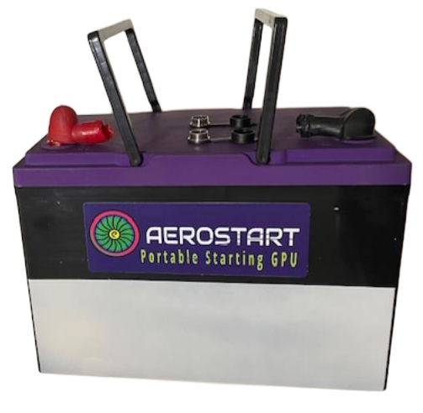
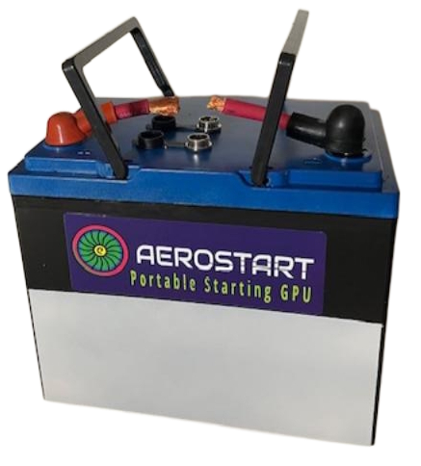

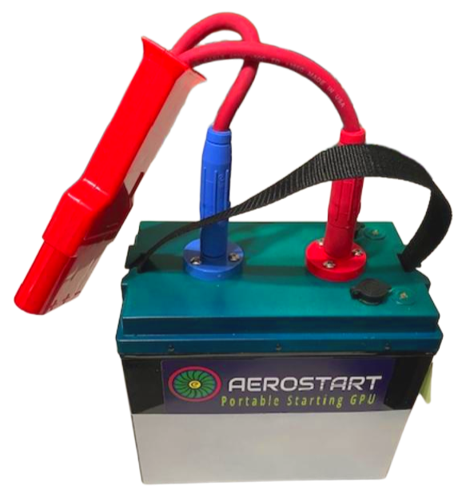
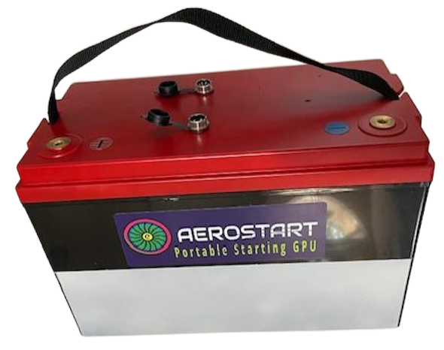
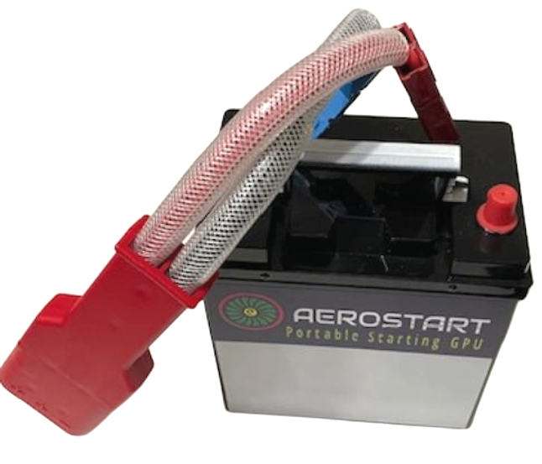

MODEL: | Heli T1/2 | T 3 | T 4 | J 5 | J 6
AH Capacity @ 1 hr rate | 11 / 16.5 | 22 | 28 | 34 | 40
Wh Energy | 308/448kwh | 448kwh | 616kwh | 924kwh | 1120kwh
Voltage – freshly charged | 27.2 | 27.2 | 27.2 | 27.2 | 27.2
Voltage – Nominal resting | 26.8 | 26.8 | 26.8 | 26.8 | 26.8
Max Current Pulse 1sec | 800 / 1200 | 1600 | 2000 | 2400 | 2800
Max continuous Amps , 20 sec | 400 / 600 | 800 | 100 | 1200 | 1400
LOAD on GPU connector T = W x L | 5.6nm / 6.2nm | 6.8nm | n/a on ground | n/a on ground | n/a
Specific Power KW ( E x I ) | 8kw | 13kw | 21kw | 38kw | 48kw
WEIGHT / MASS lb / kg | 9/4 kg -11/5 | 14 / 6.5kg | 20.0 / 9kg | 22 / 10kg | 24 / 11.0
Dimensions | 195/260,170,200 | 260x170x200 | 260x170x200 | 260x168x208 | 260x168x208
# of starts 3 minute rest | 3 | 3 | 3 | 3 | 3
life cycle x 1000 | 3 - 4 | 3 - 4 | 3 - 4 | 3 - 4 | 3 - 4
Recharge time in minutes | > 1st start - | 20-30 min. | > 2nd – 60 min | > 3rd- 90 min
Operating temps F | 30 - 150 | 30 - 150 | 30 - 150 | 30 - 150 | 5 - 150
Torque load on connector ft/lbs | 1 | 2 | 5 | 7 | 7.7
Investment $ - Includes charger and BLUEtooth voltage monitor | $1950/2400 | $2750 | $3300 | $3800 | $4200
Compare $$ to; startpac/start-stick | 3095 to 4600 | 4600 / 5600 | Don’t have | Don’t have | Don’t have
Advantages over other older portable units;
Higher voltage maintained under load, 19 - 20V vs. 16 - 18V
Much less torquing on 3 pin connector. Different lengths cable can be fitted
THE smallest and lightest portable starting GPU’s on the market!
Utilizing the newest cell tech – SODIUM !
Very safe, non hazardous, zero maintenance
Square shaped cases with handle, a simpler more efficient case design
Bluetooth monitoring and audible low voltage alert for acft maintenance use
Heli 1 Heli 2 T3 and T4 J5 J6

