
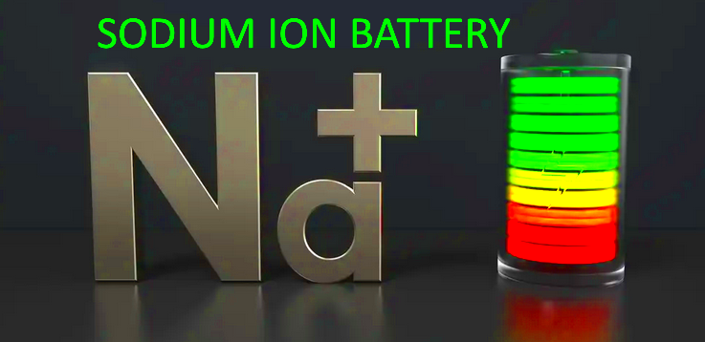

AEROSODIUM@PROTON.ME 850 844 8987 JUNE 2025
After months of research and battery designs, Aerolithium is now offering 2nd Generation
SODIUM ion cell batteries for the replacement of lead acid batteries.
Here are the benefits compared to the leading lithium and lead acid batteries in the market.
SAFETY; Sodium has ZERO propensity for any exothermic reaction; no flame, no smoke, no
internal swelling of cells, no overheating or other issues that require a ‘ fault light ‘.
As safe as LiFepo4 and lead acid may be, Sodium is even safer!
OPERATING TEMPS; Much wider range than lithium or lead. Not as sensitive to thermal issues like lithium and can accept lower charge/discharge temps than lead or lithium.
CHARGE: minus 10c/14f to 60c/140f DISCHARGE: minus 40c/f to 100c/212f
OPERATING VOLTAGES: For 12v systems 6 to 16 volts Can be discharged to zero volts w/o any cell damage. No worries about a sudden cutoff from a “smart” BMS in a lithium battery. Cannot be overcharged or overdischarged from an aircraft system. No ‘ battery fault ‘ indicator required from a delicate lithium ‘smart’ battery that must be constantly monitored.
ENERGY DENSITY: Similar to LifePO4 and absolutely higher than lead. Good engine starting performance especially in extreme temps unlike lithium.
Voltage Discharge Curve; Linear downward, making SOH and SOC easier to determine with a simple voltage display.
CYCLE LIFE: Charge / discharge and overall lifespan; = or > LiFepo4 and much longer than lead.
WEIGHT: Similar to LiFepo4
AH sizes: as needed
ENVIRONMENTAL: MUCH friendlier and more sustainable than lead or lithium.
CHARGE RATE: faster than lead acid, less demanding on your alternator than lithium
DISCHARGE RATE: ~ 40C ( Lithium up to 60C ) Self Discharge rate : < 1% per month
COST: Sodium cells are less costly to mfgr, raw material more abundant, 3/4ths cost of a comparable lithium battery.
A Sodium battery, unlike a BMS controlled ‘ smart ‘ lithium battery can act as a voltage stabilizer and accept wide voltage variations and act as a buffer from the alternator similar to lead acid without fear of an unexpected BMS shutdown causing loss of all power to aircraft.
There is no ‘ fault ‘ monitoring concerns because there are no fault weak points like lithium.
